
THE ORTHODOX CHURCH IN AMERICA

DEPARTMENT OF CHRISTIAN EDUCATION PRESENTS

IN THE BEGINNING…

A conference for teachers, parents, youth leaders,
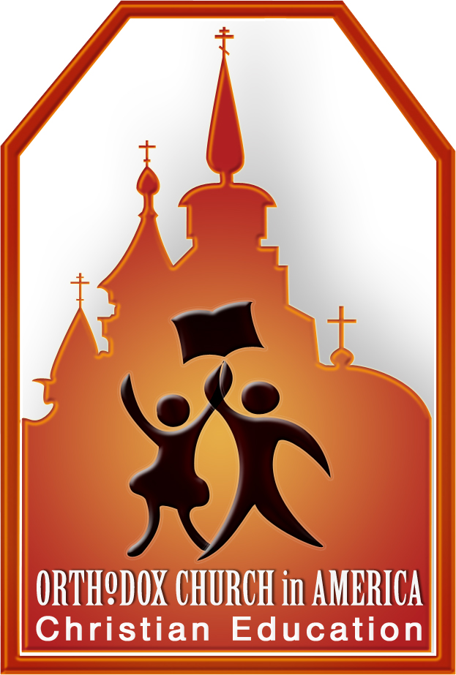
and anyone interested in Christian Education

Saturday, September 29, 2007
St. Barbara Orthodox Church (OCA)

5201 Alta Mesa Blvd., Ft. Worth, TX 76133

SCHEDULE | WORKSHOPS
9:30 AM  Registration/Coffee  10:15 AM  1st Keynote Address  His Eminence Archbishop Dmitri  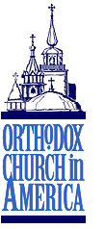  11:30 AM  2nd Keynote Address  Matushka Valerie Zahirsky  12:30 PM  Lunch/Displays and Vendors  1:30 PM  Workshops  3:45 PM  What Works?  4:45 PM  Displays and Vendors  5:00 PM  Great Vespers | - The Welcoming Classroom  - What? Who? When?  - Creative Ideas for Home and Church School  - Intercessions: Building a Thematic Lesson on Genesis  Workshops will be led by members of the Department of Christian Education (OCA)  COST  $15.00 to cover lunch, conference materials, etc. Checks payable to the Orthodox Church in America  ACCOMODATIONS  Anyone needing overnight lodging contact Matushka Christine Zebrun at  817-346-6879 or czebrun@yahoo.com

Name________________________________________________  Address_______________________________________________  City/State/Zip___________________________________________  Phone________________________________________________  Parish________________________________________________ | Are you a parent___ teacher___ student___  Number of children in your class  or at home_________  RETURN REGISTRATION TO:  Matushka Christine Zebrun  6929 Winifred Dr.  Fort Worth, TX 76133

Please let us know by mail, phone, or email if you will be attending R.S.V.P. by Wednesday, September 26, 2007.

Questions? Contact the Department of Christian Education
at christianeducation@oca.org

