THE ORTHODOX CHURCH IN AMERICA
DEPARTMENT OF CHRISTIAN EDUCATION PRESENTS

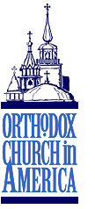
IN THE BEGINNING…
A conference for teachers, parents, youth leaders,
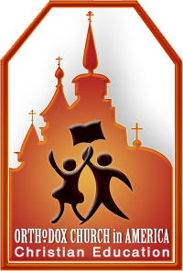
and anyone interested in Christian Education

Saturday, September 29, 2007
St. Barbara Orthodox Church (OCA)
5201 Alta Mesa Blvd., Ft. Worth, TX 76133

Conference Schedule
9:30 a.m. - Registration/Coffee
10:00 a.m. - Introductions: Very Rev. Fr. Basil Zebrun
- Acronym Icebreaker – Mrs. Daria Petrykowski
- “Housekeeping notes” – Matushka Christine Zebrun
10:15 a.m. – 1st Keynote address: “The Church’s Use of Scripture in Her Services”
His Eminence Dmitri, Archbishop of Dallas and the South
11:15 a.m. - BREAK – move to 2nd Keynote addresss

11:30 a.m. – 2nd Keynote Address: “How Genesis Can Help Our Kids Navigate Their World”
Matushka Valerie Zahirsky

12:30 p.m. - LUNCH/Displays and vendors

1:30 p.m. - Workshop I
- What? Who? When? (Mrs. Daria Petrykowski & Ms. Maria Proch)
- In the Beginning…Creative Ideas for Home & Church School (Mrs. Veronica Bilas)
- The Welcoming Classroom (Matushka Christine Zebrun)
- Intercessions: Building a Thematic Lesson on Genesis
(Matushka Valerie Zahirsky & Matushka Alexandra Safchuk)

2:30 p.m. - BREAK - move to Workshop II

2:45 p.m. - Workshop II
- What? Who? When? (Mrs. Daria Patrykowski & Ms. Maria Proch)
- In the Beginning…Creative Ideas for Home & Church School (Mrs. Veronica Bilas)
- The Welcoming Classroom (Matushka Christine Zebrun)
- Intercessions: Building a Thematic Lesson on Genesis
(Matushka Valerie Zahirsky & Matushka Alexandra Safchuk)

3:45 p.m. - BREAK
3:55 p.m. - Round Table discussions/sharing of “what works”/Panel discussion
4:45 p.m. - Displays and vendors
5:00 p.m. - GREAT VESPERS

