THE ORTHODOX CHURCH IN AMERICA

DEPARTMENT OF CHRISTIAN EDUCATION PRESENTS

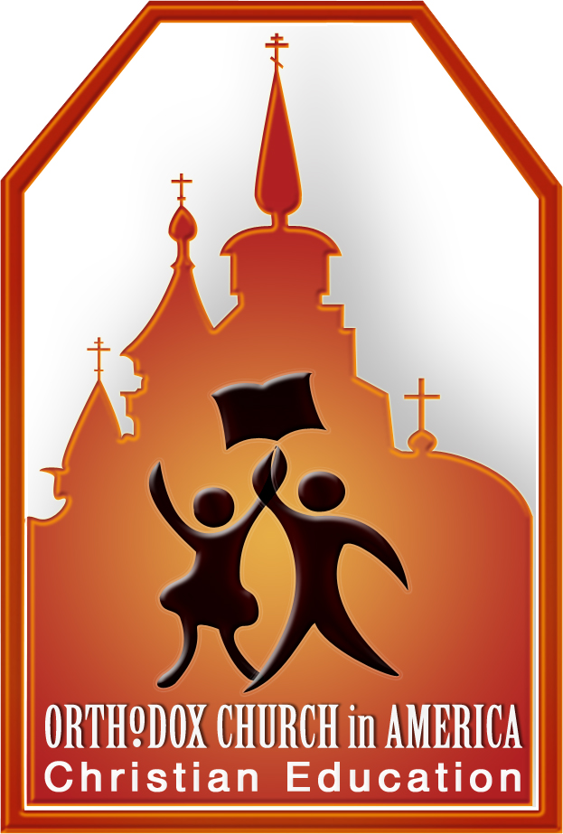
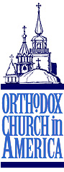
IN THE BEGINNING…

A conference for teachers, parents, youth leaders,
and anyone interested in Christian Education

Saturday, May 30, 2009

Monastery of the Transfiguration

321 Monastery Lane, Ellwood City, PA 16117-6532

SCHEDULE | WORKSHOPS
9:00 AM  Registration/Coffee  Keynote Address  Matushka Valerie Zahirsky  Lunch/Displays and Vendors  Workshops  What Works?  Displays and Vendors  Great Vespers | - The Welcoming Classroom  - What? Who? When?  - Creative Ideas for Home and Church School  - Intercessions: Building a Thematic Lesson on Genesis  Workshops will be led by members of the Department of Christian Education (OCA)  COST  $15.00 * to cover lunch, conference materials, etc Checks payable to the  Orthodox Church in America  ACCOMODATIONS  Anyone needing overnight lodging contact  Mrs. Jewelann Stefanar at  216-741-0985 or jewelann1@roadrunner.com

Name________________________________________________  Address_______________________________________________  City/State/Zip___________________________________________  Phone________________________________________________  Parish________________________________________________ | Are you a parent___ teacher___ student___  Number of children in your class  or at home_________  RETURN REGISTRATION TO:  Mrs. Jewelann Stefanar  4706 Bentwood Drive  Brooklyn, OH 44144-3153

Please let us know by mail, phone, or email if you will be attending. R.S.V.P. by Wednesday, May 20, 2009.

If you have any questions, please contact the Department of Christian Education
at christianeducation@oca.org

* In appreciation for the hospitality of the sisters of Holy Transfiguration Monastery, we ask that the registrants, if possible, please bring either paper products (paper towels, paper plates, toilet tissue) or household cleaning supplies as a charitable donation towards the continued work of the monastery and its servants. Thank you.

